* Springs provides an object factory. It gives us objects appropriate implementation based on the configuration file/annotation

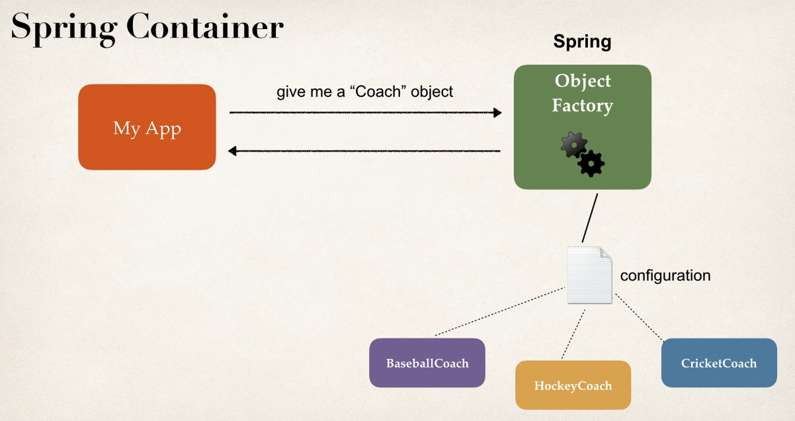

* The advantage is the configuration part, we can have different configuration and spring takes care of the object creation and other stuff.

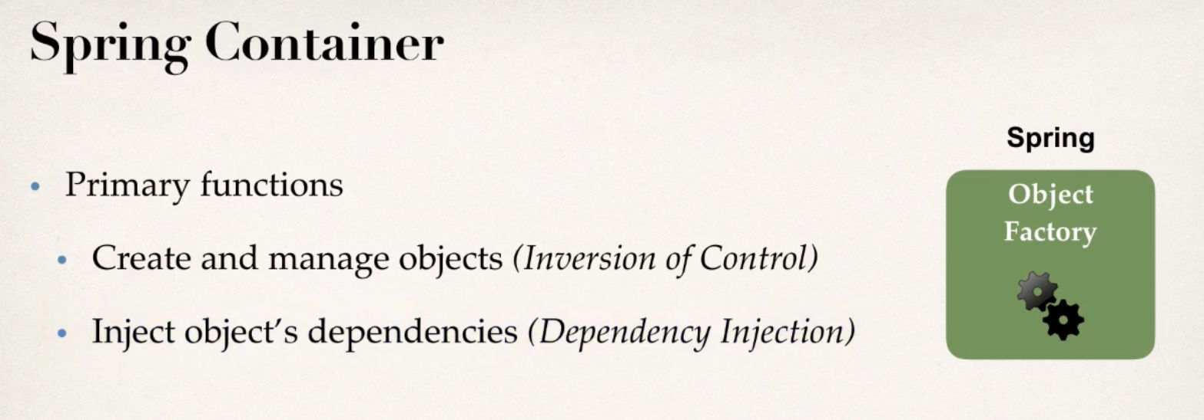

**Configuring Spring container:** Now that we know we can configure, let’s see different ways to do the configurations.

1. **XML configuration file**: Original/legacy style, most legacy apps still use it. So, it’s good to know how it works.
2. **Java Annotations**: Modern, we can get rid of the config file and do the configuration using annotations.
3. **Java source code**: Modern, we can get rid of all configuration files here. (preferred)